**DAILY ONLINE ACTIVITIES SUMMARY**

|  |  |  |  |  |  |  |  |
| --- | --- | --- | --- | --- | --- | --- | --- |
| **Date:** | **28/05/2020** | | | | **Name:** | **Imran Khan** | |
| **Sem & Sec** | **8th A** | | | | **USN:** | **4AL16CS040** | |
| **Online Test Summary** | | | | | | | |
| **Subject** | | **SMS** | | | | | |
| **Max. Marks** | | **60** | | **Score** | | **54** | |
| **Certification Course Summary** | | | | | | | |
| **Course** | **AWS training** | | | | | | |
| **Certificate Provider** | | | **AWS** | **Duration** | | | **100minutes** |
| **Coding Challenges** | | | | | | | |
| Problem Statement: Given an array arr[] of size N and an integer K. The task is to find the last remaining element in the array after reducing the array. | | | | | | | |
| **Status: Solved** | | | | | | | |
| **Uploaded the report in Github** | | | | **yes** | | | |
| **If yes Repository name** | | | | **Imran040** | | | |
| **Uploaded the report in slack** | | | | **yes** | | | |

**Online Test Details:**

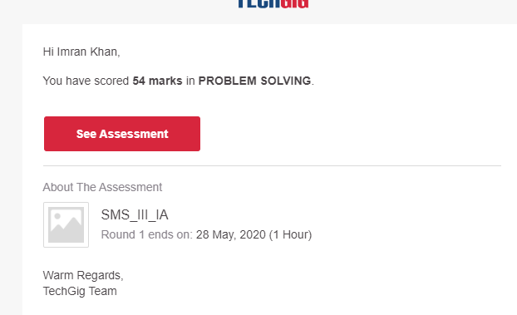

**Certification Course Details**:

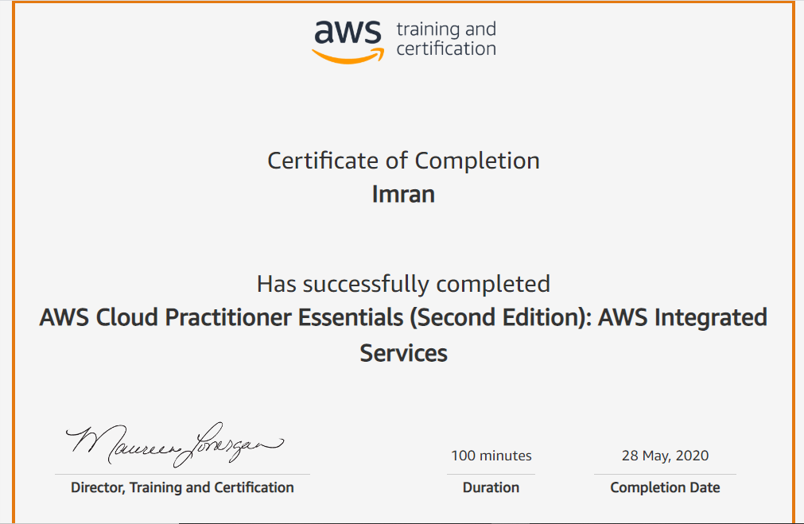

**Coding Challenges Details**:

**program1:**

|  |
| --- |
|  |
| #include<stdio.h> | |
|  | | #include<conio.h> |
|  | |  |
|  | | int main() |
|  | | { |
|  | | int n, k, arr[10], sum = 0; |
|  | |  |
|  | | printf("Enter the value of n: "); |
|  | | scanf("%d",&n); |
|  | |  |
|  | | printf("Enter the %d numbers: ", n); |
|  | | for (int i = 0; i < n; i++) { |
|  | | scanf("%d", &arr[i]); |
|  | | } |
|  | |  |
|  | | printf("Enter the value of k: "); |
|  | | scanf("%d",&k); |
|  | |  |
|  | | for (int i = 0; i < n; i++) { |
|  | | sum += arr[i]; |
|  | | } |
|  | | sum = sum % k; |
|  | | printf("%d", sum); |
|  | | return 0; |
|  | | } |